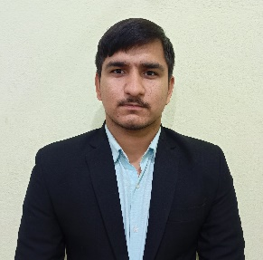Registration Number: 22BAI10283 Email: [manish2022@vitbhopal.ac.in](mailto:manish2022@vitbhopal.ac.in)

# Phone: +91 8307649067

<https://www.linkedin.com/in/manish-yadav-2m>

<https://github.com/manishyad375375>

Manish

**Technical**: GIT, Linux, Python, SQL, FastAPI, MongoDB, PowerBI, Advance Excel

**Certification:**

* Python, Vityarthi
* Introduction to Data Science with Python, Nov 23-ongoing
* Applied Machine Learning in python, Coursera

|  |  |  |  |
| --- | --- | --- | --- |
| EDUCATION | | | |
| Board | Tenure | Educational institution | CGPA/Percentage |
| B. Tech (CSE)  AI & ML | Oct 2022 –Ongoing | Vellore Institute of Technology ,Bhopal | 7.11 |
| Class XII | May 2020 | Bharti Public School, Narnaul | 81% |
| Class X | May 2022 | Bharti Public School, Narnaul | 81% |

|  |  |
| --- | --- |
| ACADEMIC PROJECTS | |
| Sentimental Analysis | * Sentimental Analysis of Amazon   + Description: Sentimental Analysis of Reviews   + Technology: Python (Numpy, Pandas, TextBlob)   + Project Type : Individual |
| Diet Recommendation System | * Diet Recommendation System   + Recommend Diet using BMI and BMR   + Technology: Python, Streamlit, FastAPI   + Project Type: Team   + Members: 5   + Backend(ML model) |

|  |  |  |
| --- | --- | --- |
| **CO-CURRICULARS** | | |
| Coding | * HackerRank 5 Star in Python |

|  |  |
| --- | --- |
| EXTRA-CURRICULARS AND ACHIEVEMENTS | |
| Responsibilities | * Been in management team for various activities and events in school |
| Extracurricular | * I am Black Belt holder in Taekwondo * Won Medals at District, State and National Levels in Taekwondo. |

|  |  |
| --- | --- |
| ADDITIONAL INFORMATION | |
| Hobbies | * Photography: Landscapes and night trails, Martial arts |
| Languages | * English, Hindi |